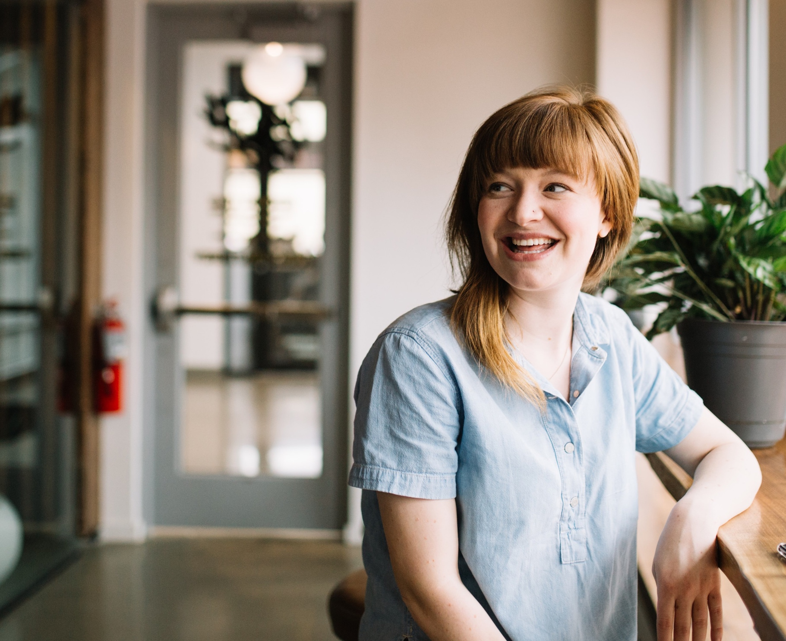

Disability Action Plan 2022-2024

Making advertising work better for people

Acknowledgement of Country
We acknowledge the Traditional Custodians of the lands on which GroupM works, and pay respect to Indigenous Elders past, present and emerging. GroupM recognises their continuing connection to land, sea, culture and community.

Contents 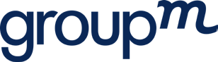

- A message from Aimee Buchanan, GroupM CEO

- Introduction

- Our story

- What is this plan for?

- Our stories: Daniel Benton, General Manager, Neo

- Our stories: Jessica Cragg,
SEO & CRO Analyst, Wavemaker

- How are we going to do it?

- Belonging

13 Business

16 Beyond

20 Acknowledgements

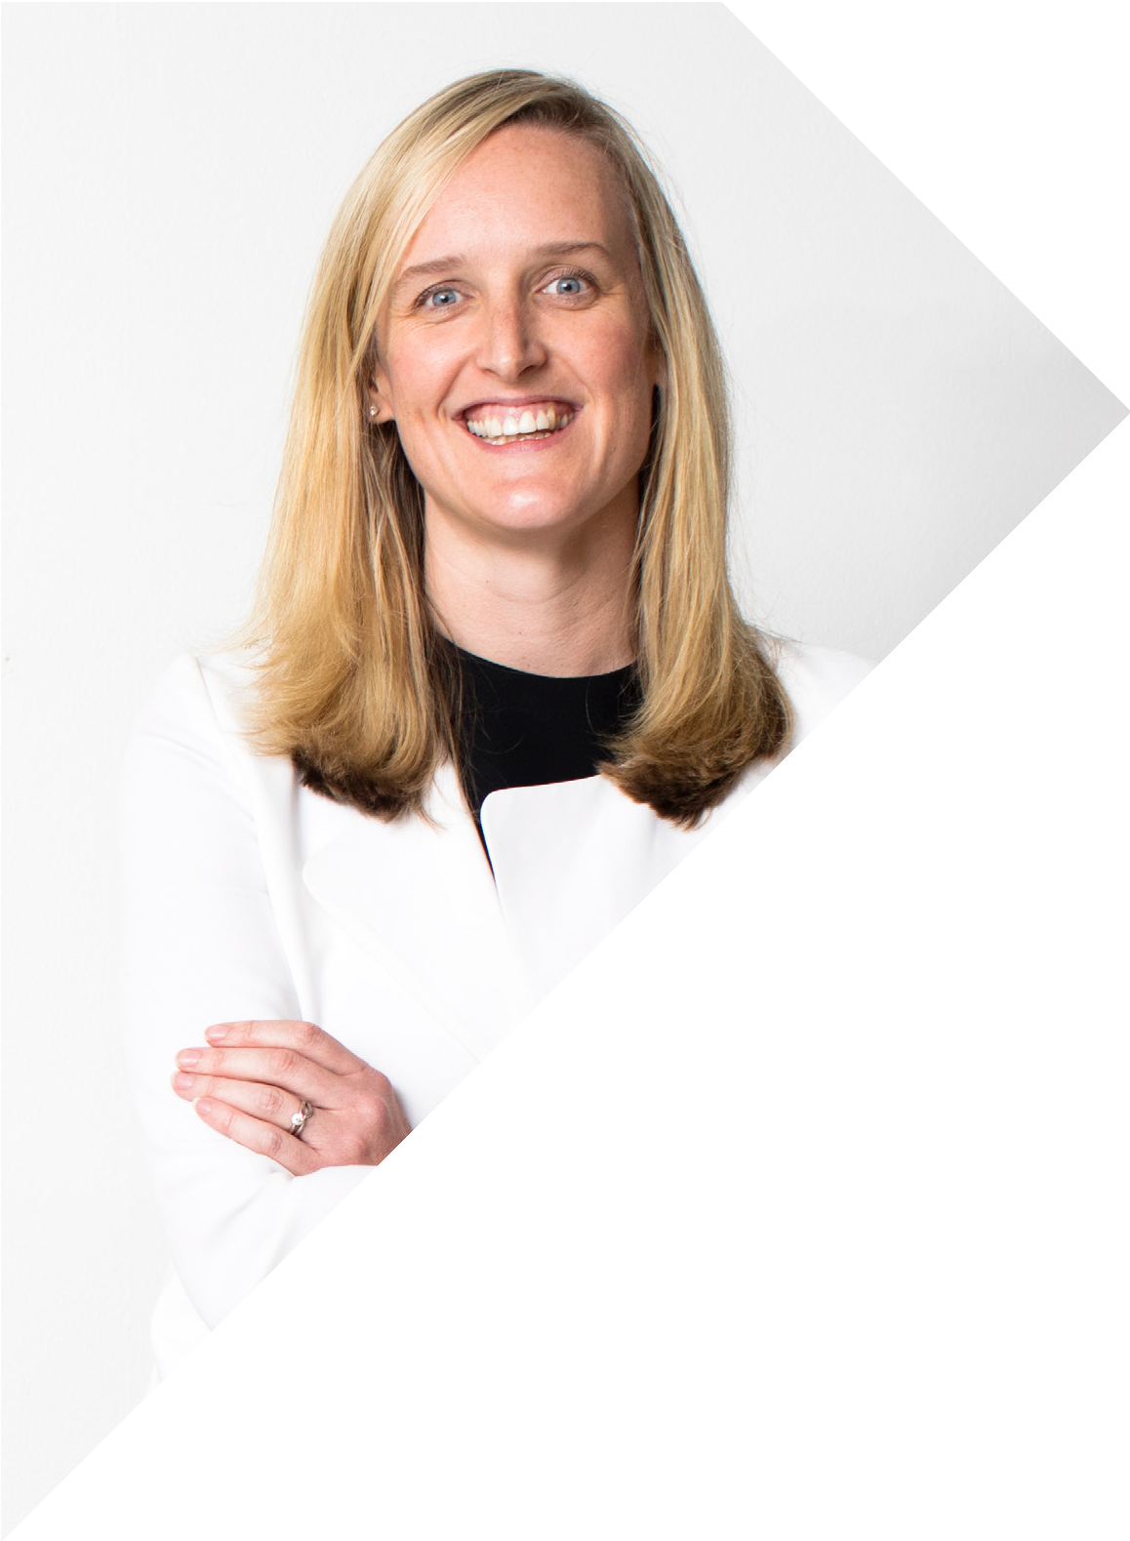
A message from Aimee Buchanan, GroupM CEO

“Our disability action plan tackles a topic that deserves more airspace in the D&I arena for our industry. It has inclusivity at the heart and the opportunity to impact so many people for the better.

It is an action plan built from a place of passion and real-life experience, with so many of our DAP committee members wanting to see change for themselves or their loved ones.

While disability is an area of D&I that is under- represented in the industry compared to the population, GroupM is over-represented giving us a good foundation to work from, and plenty of room to grow.

I’m excited to see the ripple effect this will have for our people, our agencies, the industry and beyond.”

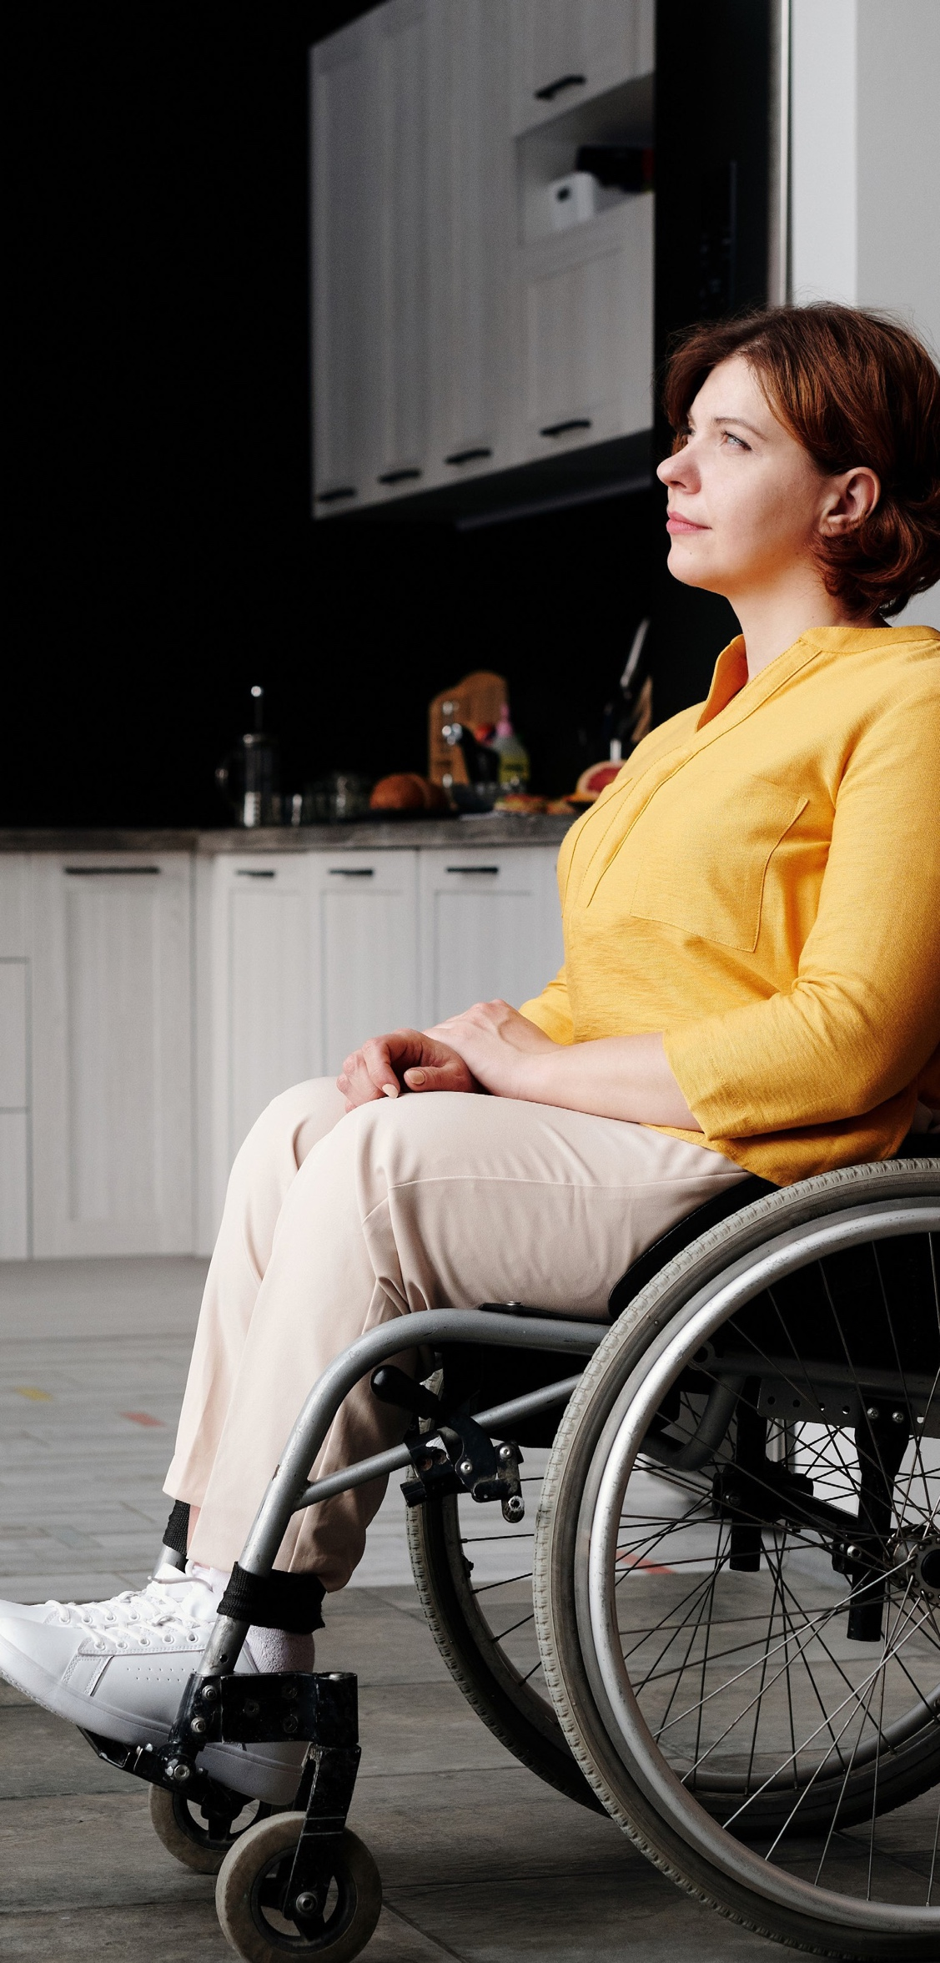
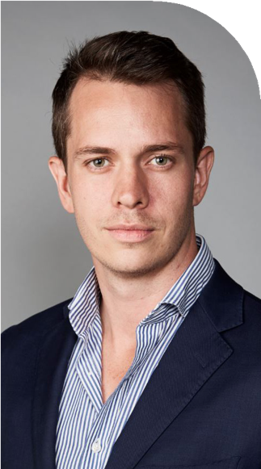
Introduction

At GroupM, our purpose is to shape the next era of media where advertising works better for people.

Our mission is to be the media investment company that is most representative of the rich diversity of the Australian population - Better for all.

This means hiring and retaining exceptional, diverse talent – the kind of people who are drawn to GroupM by our purpose of making advertising work better for all people.

Our ambition is to create workplaces where our people feel not only that they have opportunities to thrive, but also that they are celebrated. We will offer every person the opportunity to learn, grow, and do amazing creative work, surrounded by
leaders and colleagues who are inclusive and kind. We believe that ultimately, diversity and difference will combine to produce extraordinary creativity, manifested in the work we do for our clients and the impact we have on the world.

This Disability Action Plan is just one step to ensuring that we truly achieve our mission to be Better for All.

“Diversity Equity & Inclusion at GroupM is built around our mission to be ‘Better for all’. We do this through creating a deliberate focus against our three ‘B’s. Belonging - a focus on the individual and our behaviors. Business - reviewing policies and structures within the organisation that are barriers to
inclusion. Beyond - engaging our clients and partners to join us as we launch our first Disability Action Plan. We’re excited to begin what will be the first step on our journey to delivering against our mission.”

Scott Laird
GroupM Chief People Officer

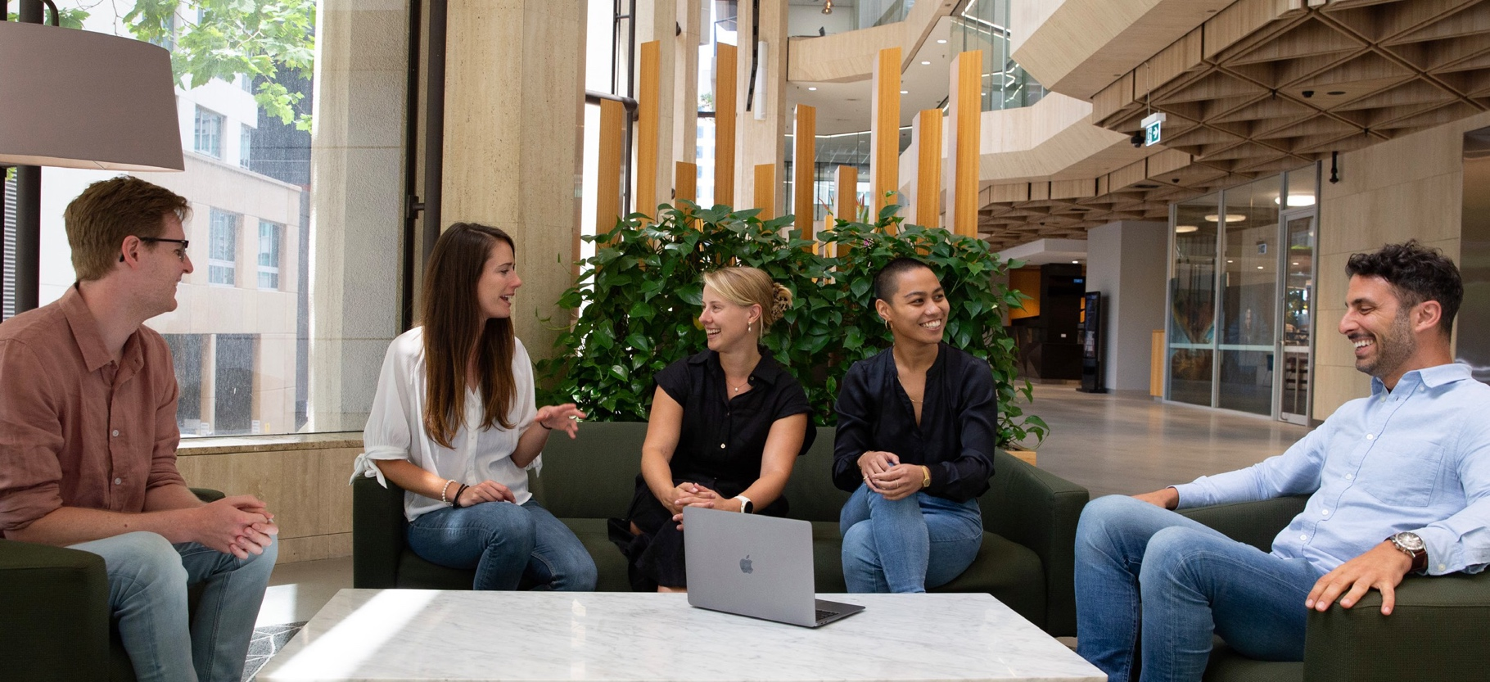
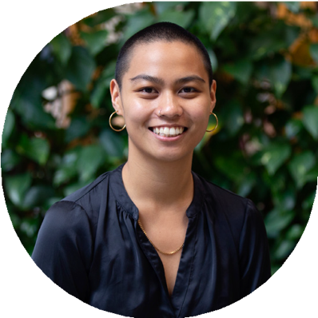
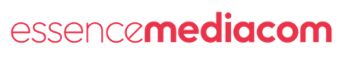
Our story

GroupM’s young leaders committee, nCo, works closely with the GroupM Executive Committee as a shadow board that represents employees and helps turn fresh thinking into action. The nCo team’s purpose is to nurture GroupM’s people sustainably and our vision is to create a workplace where all people can thrive. The team identified a need and felt passionately that they wanted to make it their mission to improve the accessibility of GroupM to those living with disability. This is where the idea of developing a Disability Action Plan (DAP) was born. The nCo team have been driving the initiative alongside a dedicated committee of passionate volunteers from across the business. They have been on a journey of listening and learning
to understand the current experience for those living with disability and working at GroupM, but also how it can be improved and how we can make a meaningful difference in the future. We’re sharing some of those stories and experiences throughout this DAP.

“While there has been a considerable growth in awareness, more action is required by businesses in Australian media. We look forward to improving access and inclusion for those living with disability. This is a particular area of passion personally, growing up with my sister, who lives with cerebral palsy, experiencing systemic and social barriers to accessing employment. Through this Disability Action Plan, my hope is that we can be one step closer to eliminating discrimination and providing equal rights
for those living with a disability – seen or unseen – within our business and beyond.”

Rachel Andrada
Strategy Associate Director, EssenceMediacom & nCo Chair

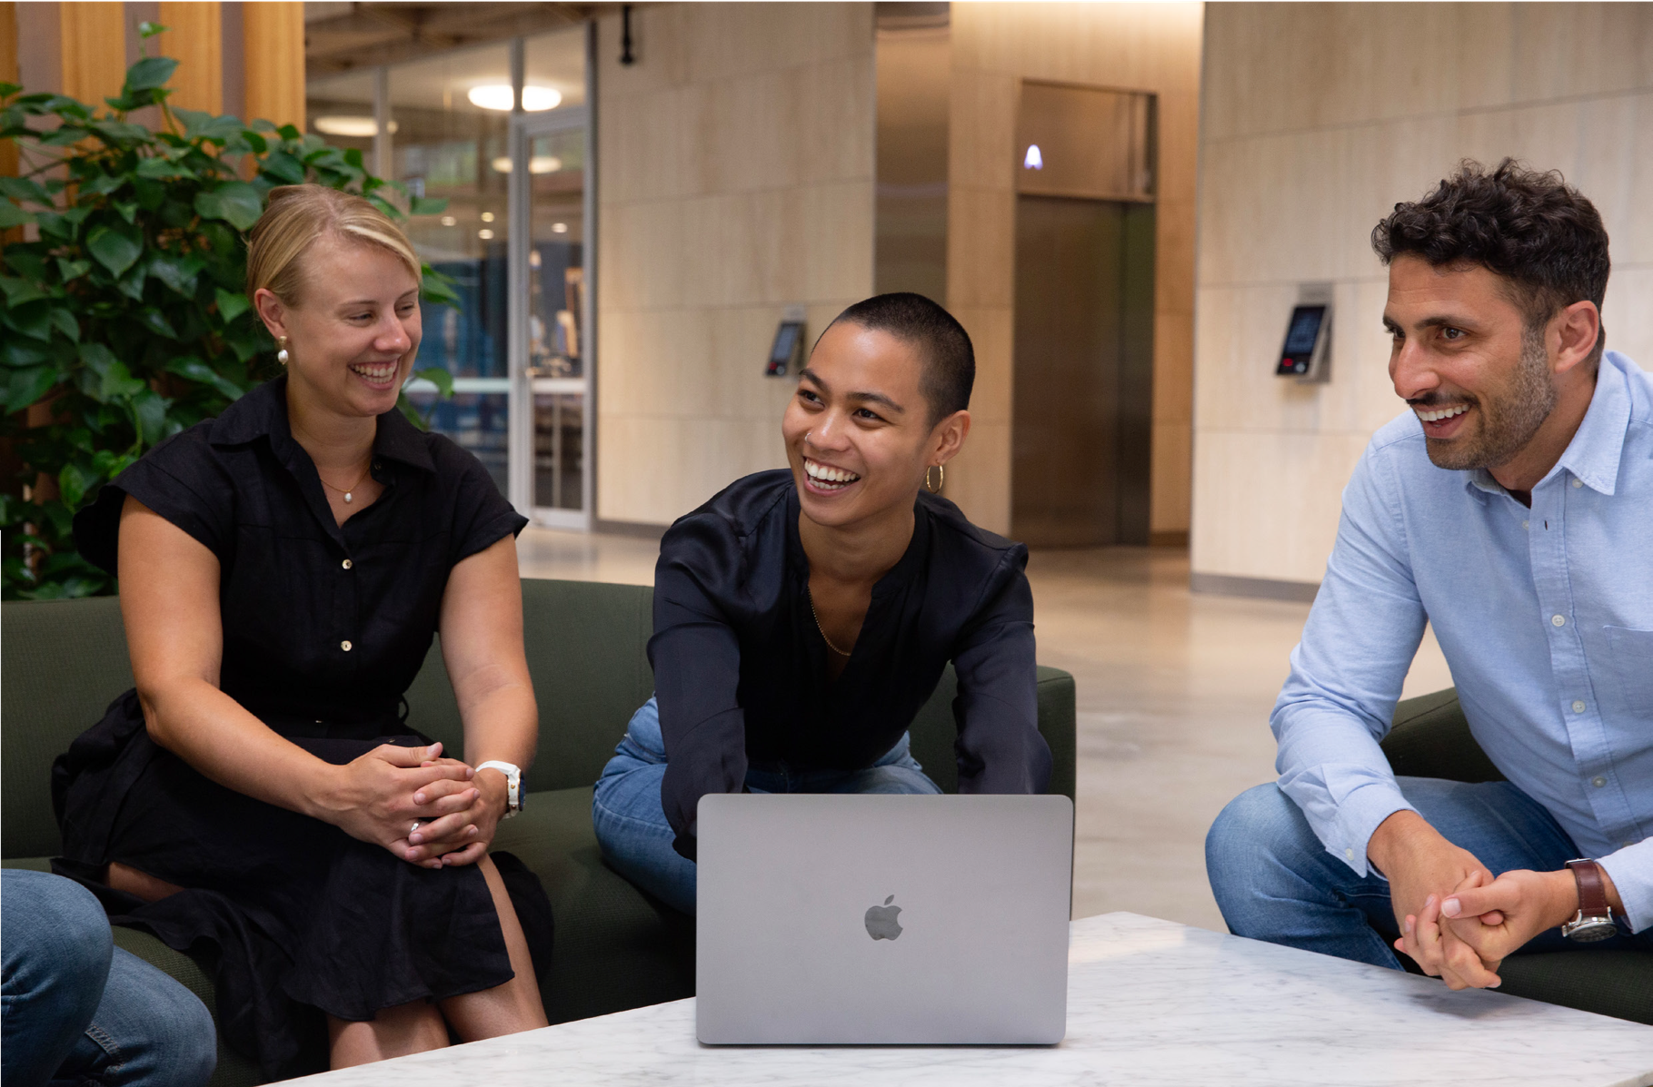
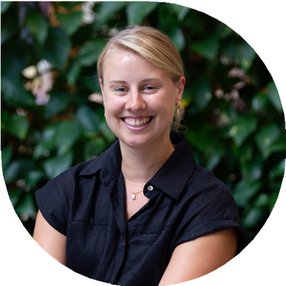
“Increasing accessibility for those living with disability is something that is very close to my heart; my brother lives with autism and I have watched his struggle to both find and hold down employment. I felt I wanted to do something to make our workforce more accessible to others with autism and my
involvement in nCo empowered me to table this as an idea with the ExCo. They were fully onboard and have given us a massive amount of support and guidance. It’s extremely exciting to finally see the DAP coming together in a physical form, but this really is only the start. We have committed to what we want to achieve, but now comes the hardest part – doing it and holding ourselves accountable. I hope this will benefit everyone at GroupM, both those living with disability and those without. This is what makes GroupM such a special place to work.”

Laura Brady
Group Client Director, Wavemaker & nCo Communications Lead
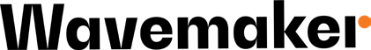

What is this plan for?

GroupM welcomes people living with a disability

This is the start of a long-term commitment. We have developed this Disability Action Plan to help us build representation, accessibility and inclusion.

Importantly, we acknowledge that Disability is a spectrum, including both physical and intellectual disabilities. Some are invisible. Therefore, we intend for this Action Plan to benefit individuals, families, friends, coaches, carers and volunteers.

People with disability in Australia 2022:
1 in 6 people in Australia are estimated to have disability
48% of working-aged people (15-64) with disability are employed, compared with 80% without a disability

17% of people with a disability aged 15-64 experience social isolation, compared with 8.7% without disability

Source: AIHW

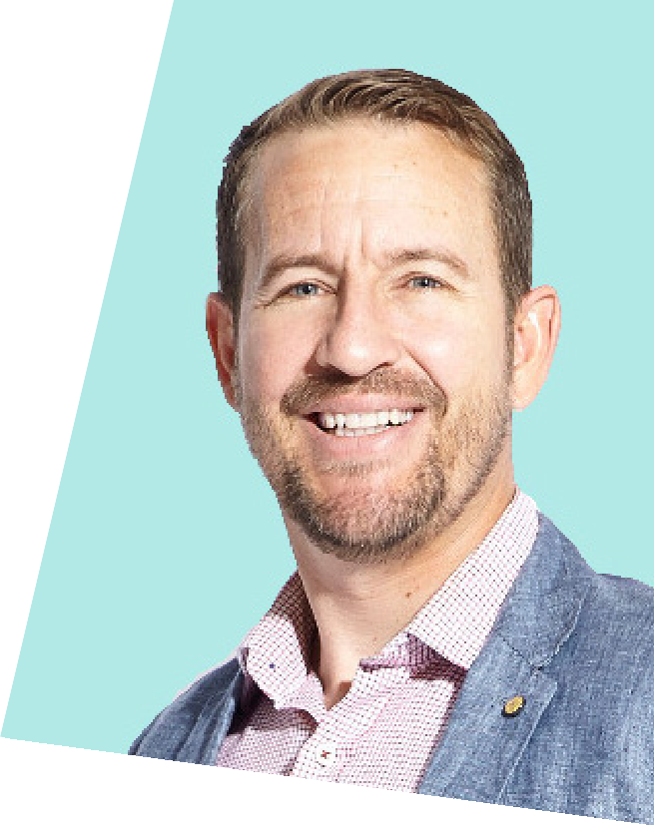
Daniel Benton’s story

“The creation of GroupM’s disability action plan is an important step to build a workplace that is truly inclusive across all dimensions of diversity.

As the parent of a child with additional needs, I am a passionate champion for this initiative.

It has the potential to provide a pathway for overlooked talent cohorts to build rewarding careers in media and to positive inspire other businesses to embark on their own DAP journeys.

I’m hopeful in years to come we can reflect on the impact the DAP has made in broadening the diversity in our industry and in providing opportunities for some of the over 4 million Australians who have a disability to work in media.”

Daniel Benton
General Manager, NEO

Jessica Cragg’s story

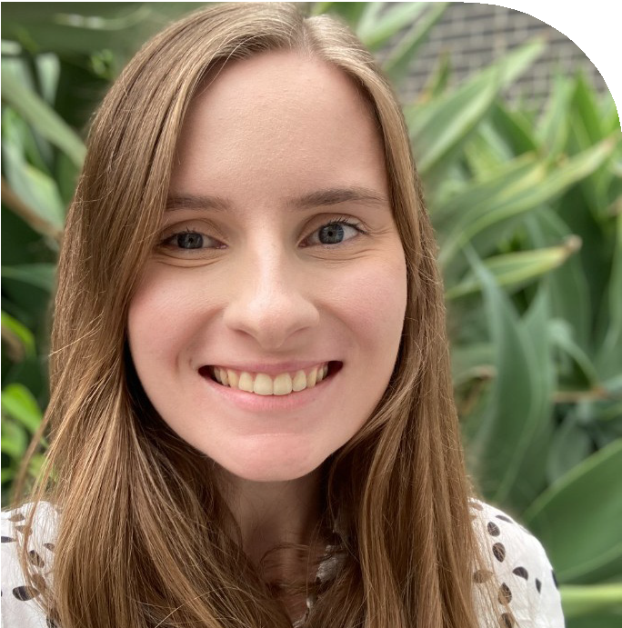
Background

In January 2017 I acquired autoimmune encephalitis and lost most of my memory from 2015-2017. The next few years that followed were a long process of both relearning the first year of my degree, but also adjusting to a new life with epilepsy and accepting that most of 2015-17 was gone. Despite all this, I
completed my degree and now read voraciously, having read 71 books in 2021, and 25 so far for 2022.

How the team have supported me

At Wavemaker, my team has always been supportive and made every effort to create an environment that caters to my needs. Whether this be a lighter workload on days when I’ve had a seizure, or flexible time around specialist appointments.

What the DAP means to me

I got involved because I want to see a more inclusive environment for all. A workplace where disability isn’t an afterthought in working styles and environment. Where people feel comfortable disclosing living with a disability and then feel comfortable bringing their experiences to the table. This is where progress starts and creativity flourishes.

A workplace for all is where not just our internal resources are inclusive. If we are truly to attract a more diverse workforce, we need all our public facing resources to also reflect this. This includes how we communicate and the options we provide in communication.

The onus should be on us as a company to make GroupM more inclusive and this starts with the DAP. The DAP will be the beginning of listening, learning and being challenged so that GroupM better reflects a workplace for all.

Jessica Cragg
SEO & CRO Analyst

How are we going to do it?

We are committed to monitoring our level of representation of people living with a disability. In 2022, GroupM created its Disability Action Committee with the aim of enabling access, inclusivity and representation through making GroupM a disability-ready employer. This group comprises people living with a disability, families, friends, carers and passionate individuals, committed to minimising blindspots to improve inclusivity and access in Australia.

The DAP committee has audited GroupM’s readiness, current gaps and opportunities, and the actions required to make this a reality. The following document will outline our roadmap to achieving this aim.

This plan covers GroupM’s commitments from 2022 - 2023 built on three priority areas: Belonging, Business & Beyond.

Peers
- Belonging
Partnerships

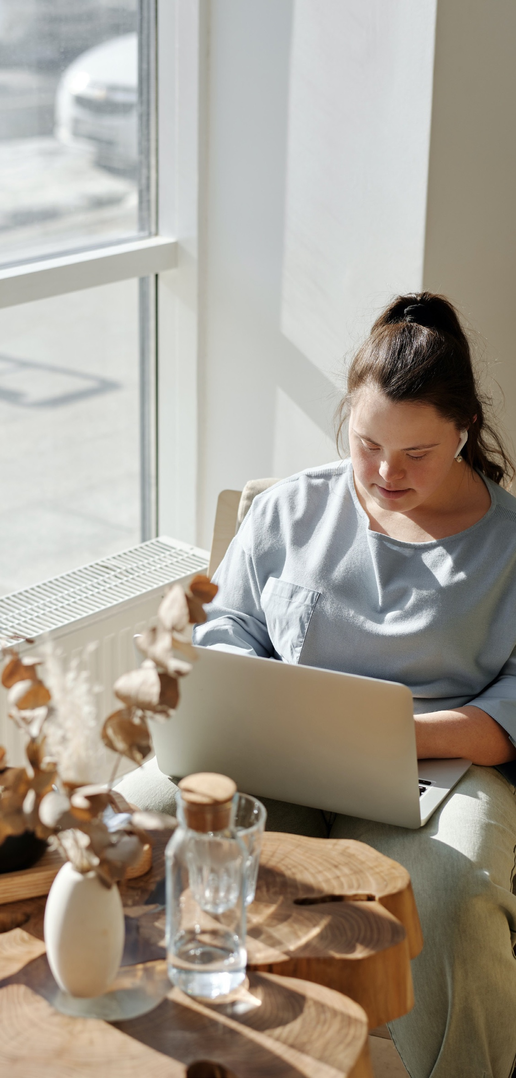

- Business 3. Beyond

Principles

The next pages will detail these priorities, including the actions, roadmap and personnel involved for each area.

GroupM Disability Action Plan Page 8

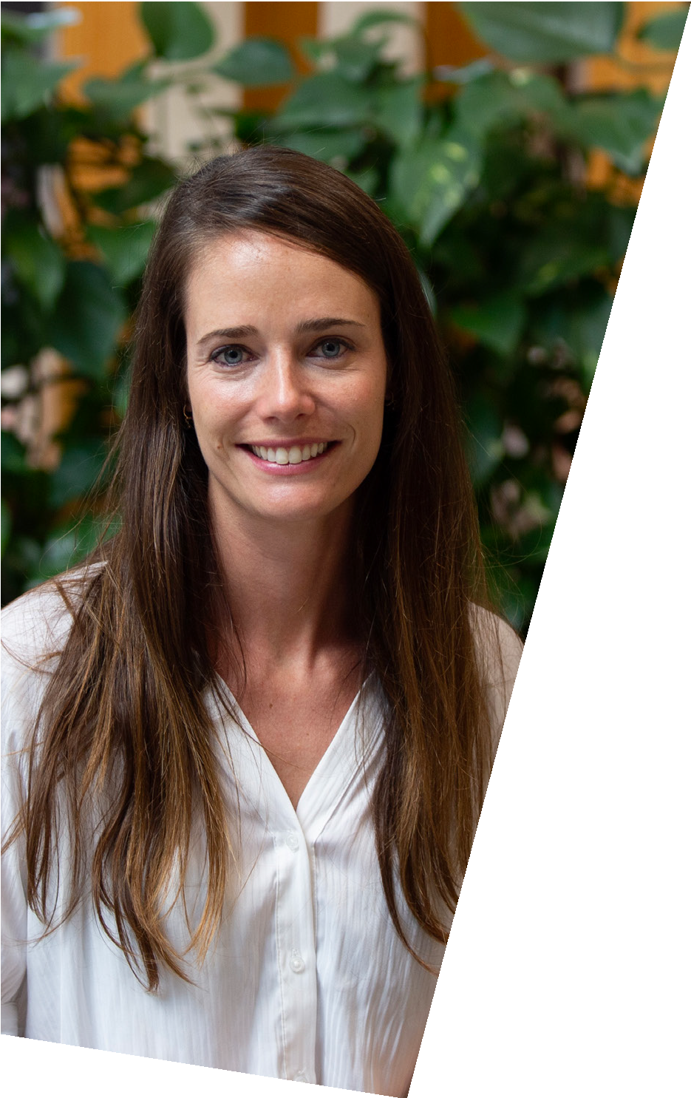
Belonging

Our purpose is to understand our people. Understanding how people living with a disability feel in the work environment and how people without a disability understand inclusion. We want everyone
at GroupM to feel like they belong and therefore we need to adapt the environment to be a diverse and inclusive place.

“It’s really important to support GroupM employees with a disability and understand their challenges. It’s a big step for GroupM and we are all really proud to be a part of it.”

Eva Del Rio Garcia
Wavemaker, Paid Social Manager

Belonging

Action Deliverable

Understand the workplace experience for
those living with a disability
Conduct an annual survey to understand staff sentiment surrounding inclusion for people living with a disability.

Run focus groups to gather in-depth feedback on disability, accessibility and inclusion.

Timeline: Q1 2023
Responsible: People Team, DAP Committee

Ensure adequate disability inclusion training across GroupM
Increase awareness and understanding of disability. Aim for 60% completion (stretch 80%) across GroupM of the SBS disability module by 31st Dec 2022.

Timeline: Dec 2022
Responsible: People Team, DAP Committee, MDs, DAP Allies

Work to normalise the conversation surrounding disability
Increase visibility of disability across the Group.

Recognise moments of symbolism / importance for people living with disability.

Timeline: Start Q1 2023, ongoing
Responsible: DAP Committee, EXCO, CEOs

Support Progression of Talent with Disability
Measure progression of talent with disability through an annual audit to ensure equal growth, progression and opportunity.

Remove barriers & obstacles for progress for those living with disability across the Group.

Timeline: Q1 2023
Responsible: DAP Committee, People Team

Belonging

Action Deliverable

Ensure that our recruitment process is accessible for all
Input a statement into every GroupM JD to communicate that ‘GroupM is an inclusive employer. We encourage all people to apply for this role including…’

Conduct an audit on which roles are open.
Work with specialist agencies to identify suitable candidates, especially graduates for launchpad.

Make reasonable adjustments to the hiring process where needed.

Use Vervo platform & technology to ensure we are removing bias from our hiring process.

Timeline: Q1 2023, ongoing
Responsible: Head of Talent Aquisition to confirm wording, Talent Team to engage the recruitment agency, DAP Committee

Ensure clear communication & understanding of our Reasonable Adjustment Policy
GroupM to develop and share guidelines for all people managers on how to manage those living with a disability and ensure we make reasonable adjustments.

GroupM to create a guide for individuals living with a disability to clarify how to request reasonable adjustments.

Timeline: Q1 2023
Responsible: People & Talent Team, DAP Committee

Belonging

Action Deliverable

Ensure our onboarding process is fully inclusive
Include an opt-in section to disclose disability on all new starter forms.

Ensure we use this to measure and track candidate diversity.

Include a link to the DAP & any relevant resources in all recruitment and new starter packs.

Timeline: Start Q2 2023, ongoing Responsible: DAP Committee, EXCO, CEOs, MDs, HR Leads

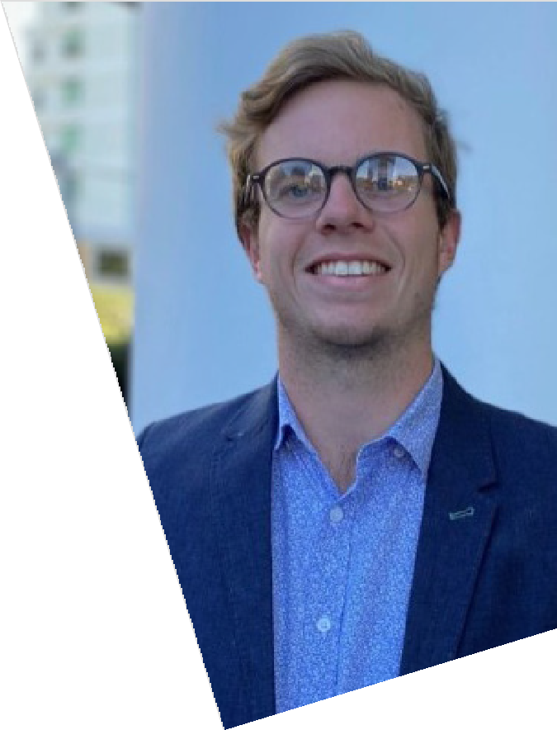
Business

We want to ensure that all GroupM workspaces are adequately prepared and suited for any and every employee who identifies as having a disability. We intend to start with an audit of where we fall short via a survey of employees. We will then use the learnings to equip GroupM work spaces with any necessary adjustments.

Furthermore, due to travel being such a large part of our job, we want to assess whether our travel
partners provide acceptable accessibility options and address provisions.

“It’s so important that we ensure all GroupM work spaces are prepared for current and future employees who identify as having a disability.
If we can create a working environment where everyone, no matter who they are, can feel welcome. Then that is something to be truly proud of.”

Harry McCutcheon
Prism Partnerships Co-ordinator
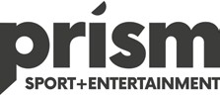

GroupM Disability Action Plan Page 13

Business

Action Deliverable

Identify gaps in safety and
accessibility in the workplace and its visitors
Conduct an annual feedback survey to gather feedback from all staff on disability, inclusion and accessibility sentiment in all physical GroupM workspaces.

Run focus groups to gather in-depth feedback on disability, inclusion and accessibility sentiment in all physical GroupM workspaces.

Analyse findings and make recommendations to a
commitment for current and future needs.

Timeline: Q1 2023
Responsible: DAP Committee (support of HR and agency leads)

GroupM Disability Action Plan Page 17
Page 14

Business

Action Deliverable

Increase awareness with building stakeholders (e.g. landlords and WPP)
Build proposal and action plan to share with building management across all markets, requesting adjustments to meet accessibility standards.

Timeline: Q4 2022
Responsible: DAP Committee (support of HR and
agency leads), Office Managers

Increase awareness within GroupM
Create, circulate and promote wrap up resource to empower GroupM employees to discuss workspace commitment.

Timeline: Q1 2023
Responsible: DAP Committee (support of HR and agency leads), Communications & Marketing Leads

Assess accessibility of preferred travel and accommodation options
Request reporting and availability of accessibility within travel/accom providers.

Adjust booking/travel forms for declaration/request of accessibility aid.

Make declaration to travel/booking partners of what GroupM’s requirements are.

Timeline: Q1 2023
Responsible: DAP Committee (support of HR and agency leads), Office Managers and Travel Bookers

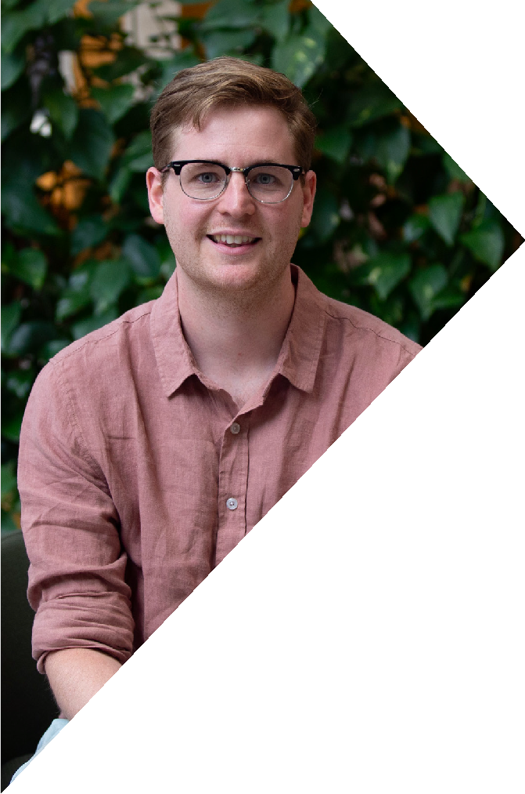
Beyond

We are striving to make an impact not only on our own business and people, but also on the broader industry. We want everyone who partners with GroupM, our clients, publishers, and industry bodies, to understand this pillar of inclusivity and to make genuine change in their own organisations.

The goal is to ensure that each individual feels included in any situation and their relationship with our external stakeholders.

“The Disability Action Plan is a terrific initiative for GroupM that I am proud to be a part of. I’m excited to bring this to our partners in the hope that it broadens the impact in making our industry more inclusive and accessible.”

Jon Windred
Neo Performance Manager

Beyond

Action Deliverable

Establish & strengthen strategic partnerships with key organisations
Identify stakeholders & organisations within our
sphere of influence.

Conduct fundraising & pro-bono work with charity organisations.

Ensure industry events are accessible (with the help of MFA) with agency feedback as to what could be improved.

Timeline: Q1 2023, ongoing
Responsible: DAP Committee, HR Leads, CEOs

Improve communications to be accessible & inclusive
Create a best practice guide and training module to be distributed amongst the agencies.

Make our public statements accessible to those living with a disability & easily understood (e.g. Braille, CCs, Auslan and Audio).

Ensure our websites and job descriptions are
multi-sensory through enabling audio and dictation options. Alt Attributes are applied on images to assist with visual impairments.

Highlighting our plan with partners & using the correct vernacular in each interaction.

Timeline: Public Statements & Site Accessibility Q1 2023; Plan with Partners Q3 2023 Responsible: Talent team led by Chief People Officer; GroupM IT/Developers; Comms teams & Investment leads

Beyond

Action Deliverable

Increase supplier diversity, to support economic & social outcomes
Modify the group purchasing to include a section on suppliers that advance and support the needs of those living with disabilities.

Extending the inclusion private marketplace across clients within GroupM and exploring new partners that have a focus on Disability representation.

Raise awareness of supplier diversity, and educate our agencies on how to engage with suppliers that advance and support the needs of those living with disabilities (e.g. BuyAbility).

Establish a process on tracking & measuring engagement with these suppliers.

Timeline: Q2 2023
Responsible: Group Procurement, DAP Committee, Investment Leads

GroupM Disability Action Plan Page 18

Beyond

Action Deliverable

Increase disability organisations’ access to skilled professionals for advice
Investigate participation with NDIS Sector Development Project.

Timeline: Q3 2023
Responsible: Group Procurement, Chief People
Officer, Inclusion & Engagement Lead

Establish a procedure for all external event locations to be accessible for all staff
Assess any location selected for GroupM events have all necessary resources for accessibility & that they are in reasonable proximity.

Communicate the accessibility standards that GroupM events are held to with all client, partner, & industry event organisers.

Timeline: Q2 2022
Responsible: Inclusion & Engagement Lead, PR & Event Organisation Leads, Communications & Marketing Leads, Office Managers

Our DAP’s success will be assessed against qualitative and quantitative measures, including:

- Actions successfully implemented over the life of the Plan – outputs and outcomes will be identified for each initiative to allow progress to be clearly measured.
- Progress measured against government, legislative, regulatory and compliance reporting requirements.
- Regularly engaging with the community and the staff that were consulted, and contributed to, the development of the plan to seek their feedback and inform the ongoing direction.
- Celebrating our success and learnings

Achievements will be noted annually in the Annual People Report

Acknowledgements
In developing our access and inclusion plan (2022-2024) we consulted widely with stakeholders including:

- GroupM CEO Aimee Buchanan and the GroupM Executive Board for their challenge, support and encouragement

- GroupM Disability Action Plan Committee

- Key Disability Action Plan Allies and representatives from EssenceMediaCom, Mindshare and Wavemaker

- External stakeholders including Industry partners and the Australian Human Rights Commission

This plan is made possible by the passion and commitment by members of GroupM’s workplace community who believe in representation, inclusivity and accessibility for all.

Further information

GroupM
Level 11, 65 Berry Street North Sydney, NSW 2060 Australia
www.groupm.com

GroupM Chief People Officer
Scott.laird@groupm.com

